ST MARYS LEGION
MINIATURE GOLF

SATURDAY 02
& SUNDAY 03 FEBRUARY 2019
10 AM TO 5 PM

ENTRY FEE – MINIMUM $5 DONATION TO THE ROYAL CANADIAN LEGION

KIDS WELCOME!

BALLS & PUTTERS PROVIDED, OR BRING YOUR OWN

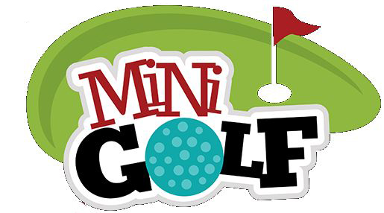
66 CHURCH STREET NORTH, ST MARYS

